Mark Mussman
Director of Education, PhD
Greater Cincinnati Homeless Coalition.
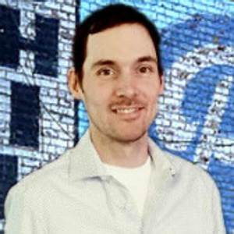
by Abigail Joseph on January 30th 2020
Mark Mussman is a Cincinnati Native and earned his PhD in Educational Studies and his M.Ed in Educational Foundations at The University of Cincinnati. Currently, he is the Director of Education with the Greater Cincinnati Homeless Coalition. He as well founded the Creative App Project in 2015, which developed the first mobile app for the Safe and Supported Initiative, a partnership between Lighthouse Youth Services, Human Rights Campaign, HUD, and many other locally-based partner organizations, aimed at reducing instances of LGBTQ+ homelessness among teens and young adults.
The Cincinnati Homeless Coalition is an advocacy group located downtown Cincinnati. This group works to eradicate homelessness in the city by creating affordable housing, and ensuring everyone has a living wage.
Questions and Answers
-Answers have be edited for length-
- What about The Coalition influenced you?
-”The coalition has influenced me by showing what collective action and power really look like. I've seen how tenants have been able to work together to fight their displacement. I have seen how people experiencing homelessness have come together to fight for civil rights. I have seen how our 65+ member organizations continually strive to provide safe and affordable housing, shelter, clothing, food, etc., yet we still face a housing crisis”

- As the Director of Education, what are ways that you reach out to the community to spread awareness?
-”The most effective way to reach out has been through the Speakers Bureau, which gives people experiencing homelessness a way to share their stories, and for our staff to help people understand the causes and solutions for homelessness, as well as other issues. Putting a face to homeless is often a life-changing experience for people who are unsure of their relation to homelessness.”

- What do you hope for The Coalition and what is your role in reaching this?
-”The ultimate goal of the Homeless Coalition is to eradicate homelessness. By educating people about the realities of homelessness, including public policy failures, gives us as a society a chance to improve.”

- What other organizations/Advocacy groups have you worked with?
-”I find myself working most directly with Peaslee Neighborhood Center, Intercommunity Justice and Peace Center, Over-The-Rhine Community Housing, The Cincinnati Interfaith Worker Center..”

.

